SQL Report
  - Section 1: SQL KPI’s
- Top Selling Products
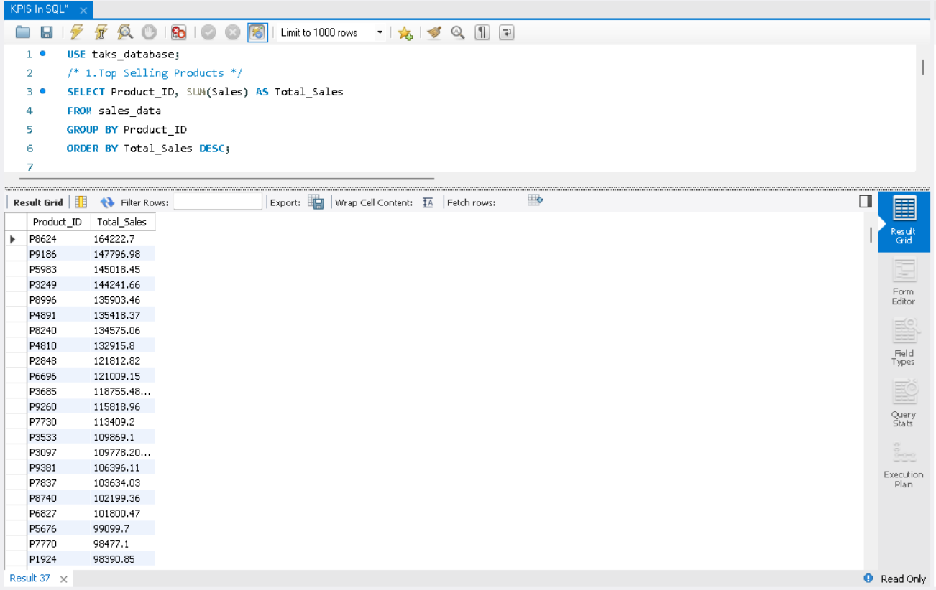

- Find the top 10 products by total sales across all categories.

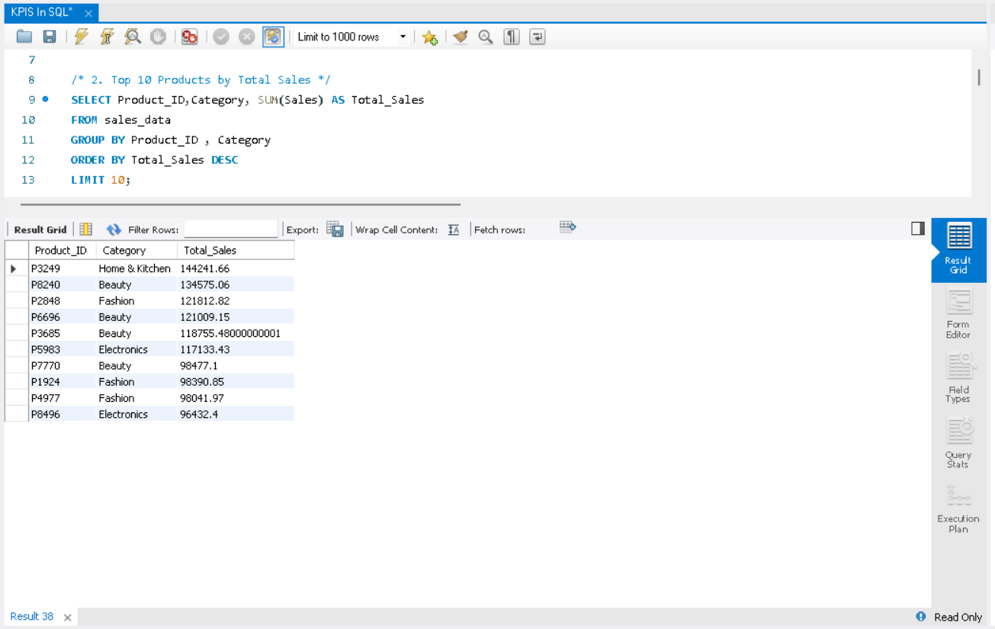
- Monthly Revenue Trend
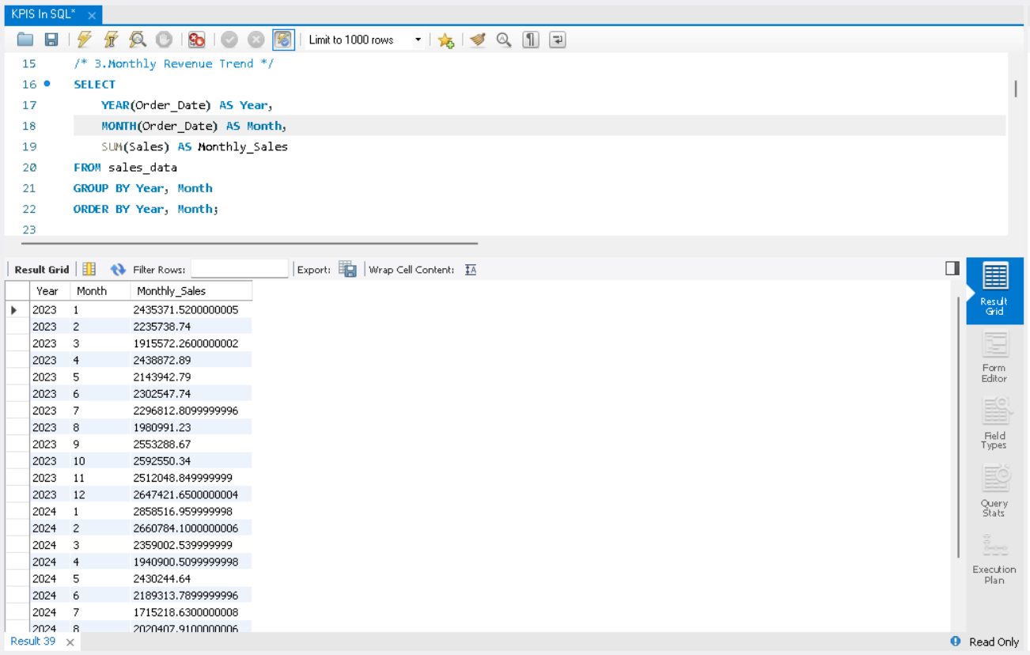

- Calculate monthly sales totals for 2023–2024.
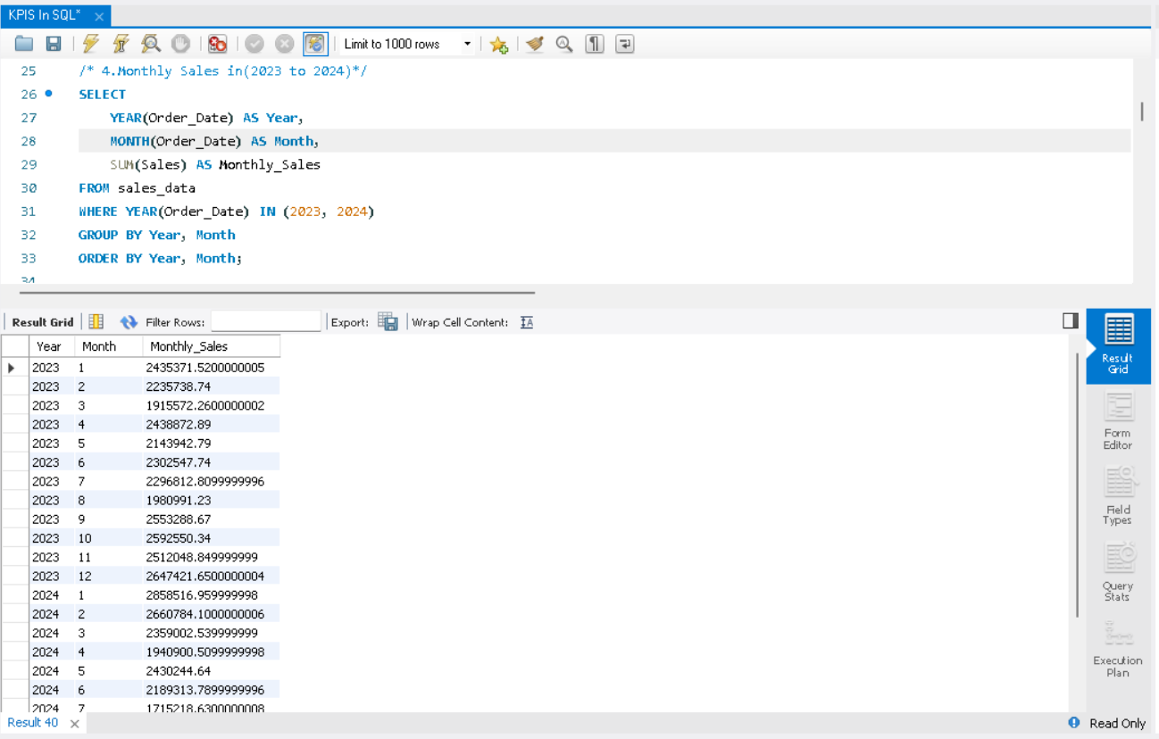

- Category Profit Analysis
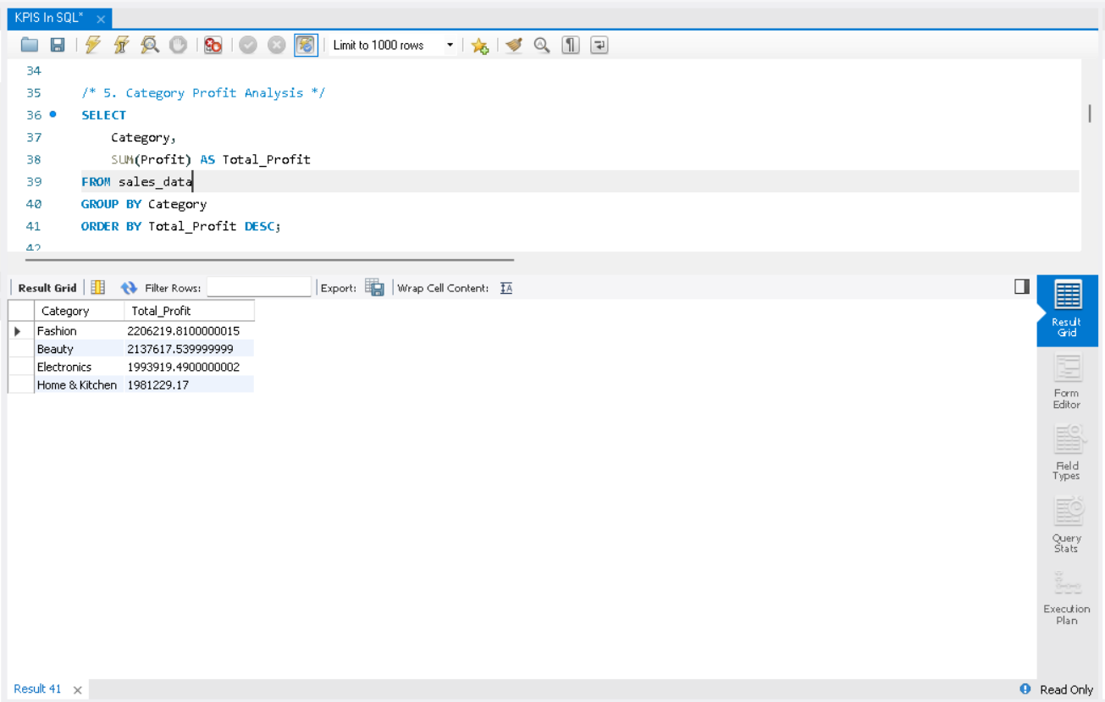

- Compute total profit and profit margin for each product category.
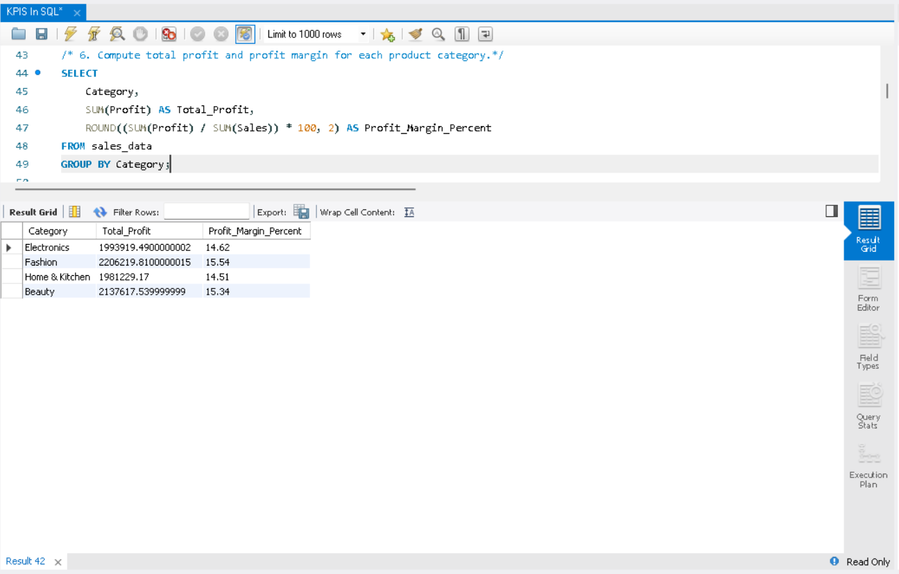

- Customer Repeat Purchases
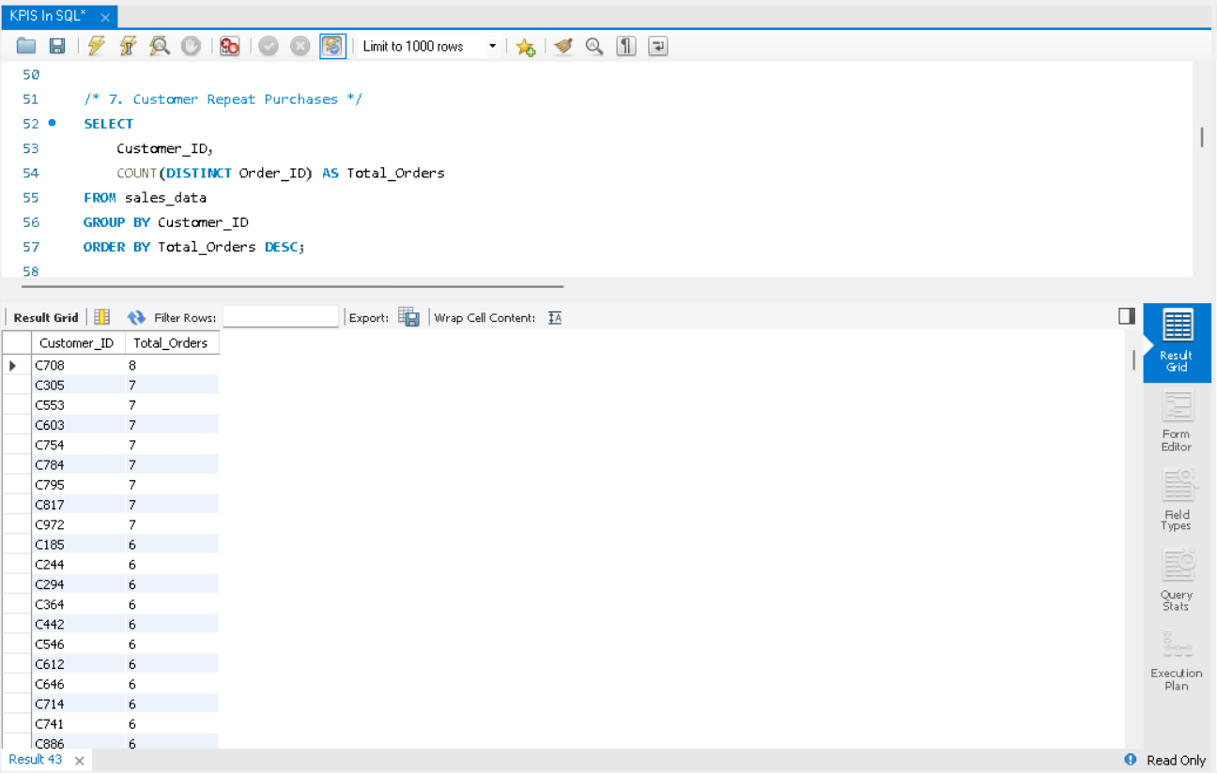

- Identify customers who made more than 3 orders in the 2-year period.
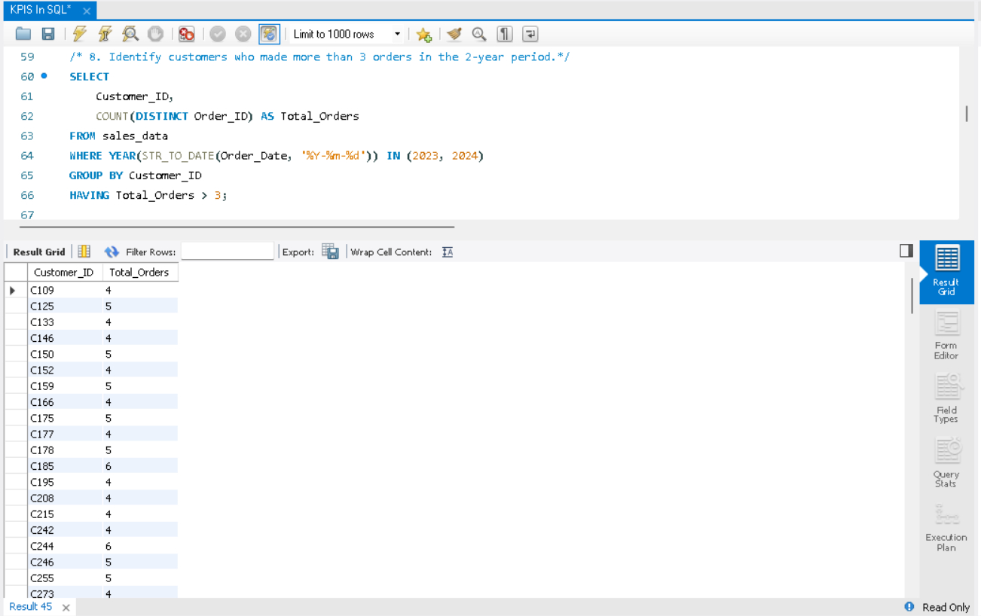

- High Discount Products
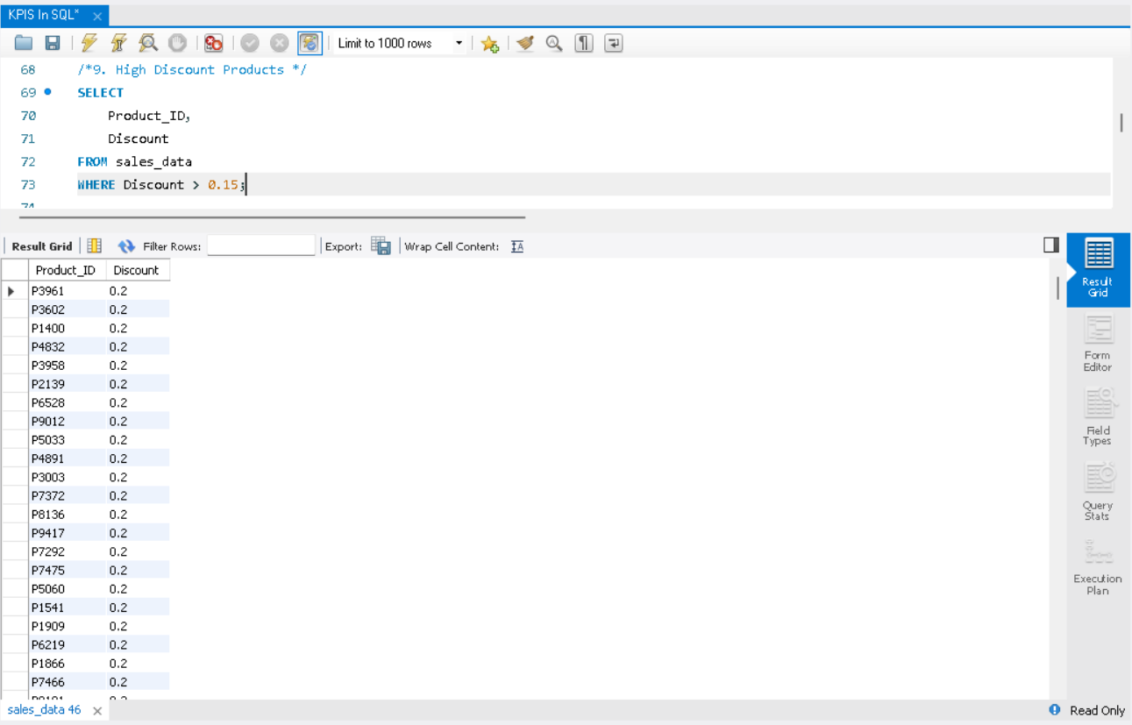

- Find products with discounts greater than 15% and their total sales.
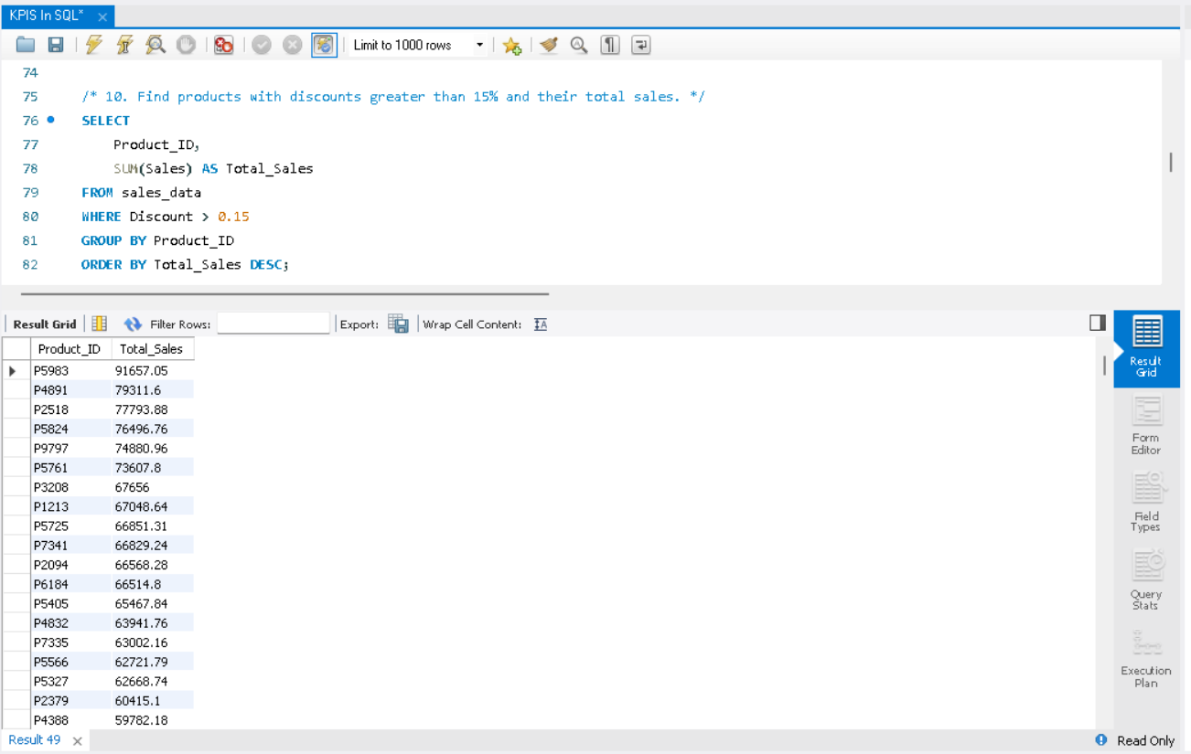

- Region-wise Sales
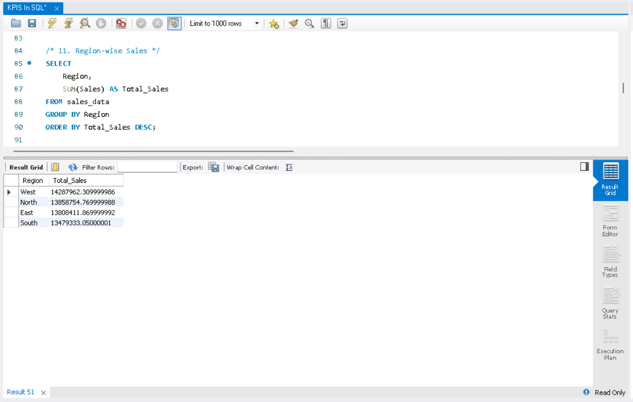

- Show total sales and average profit for each region.
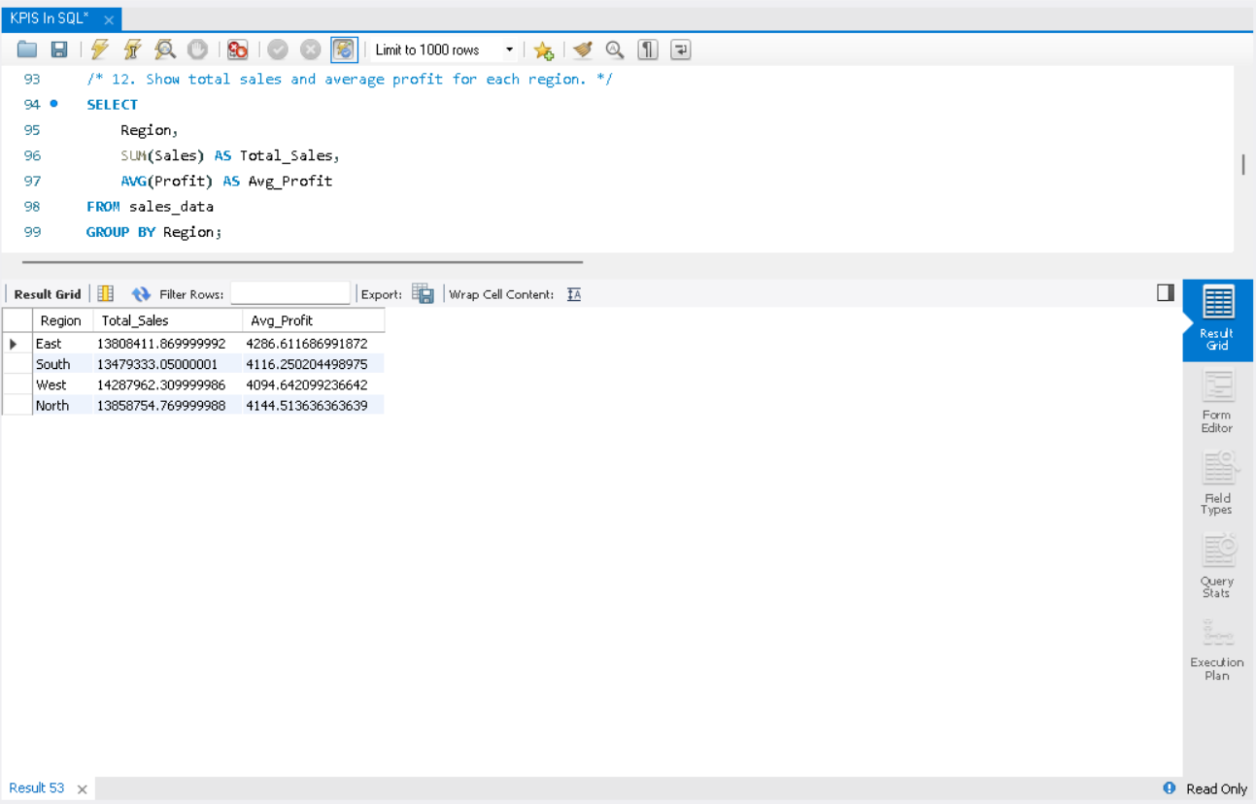

- Top Performing Brands
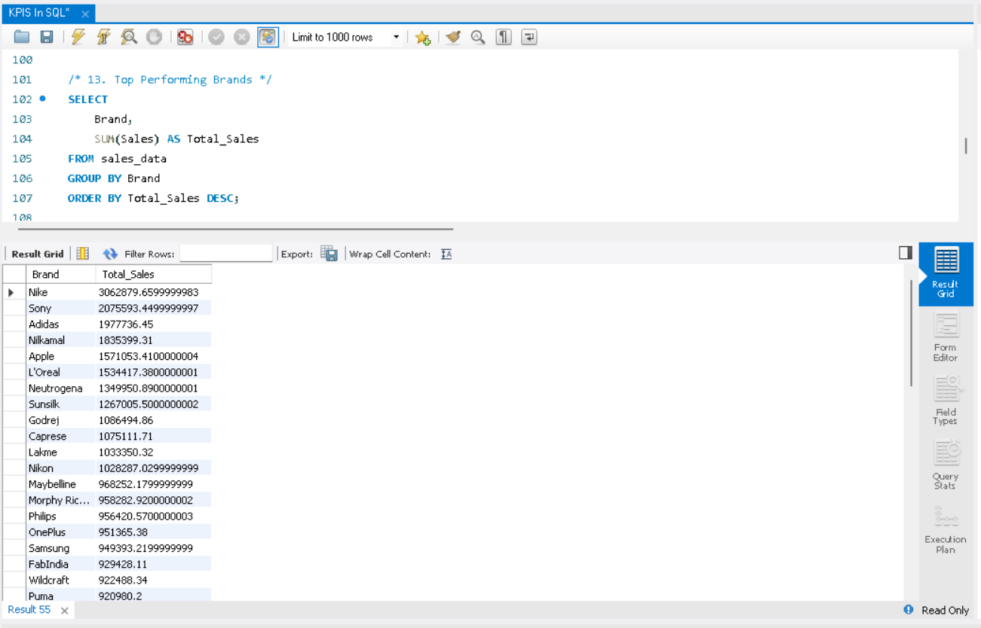

- List top 5 brands by revenue in each category.
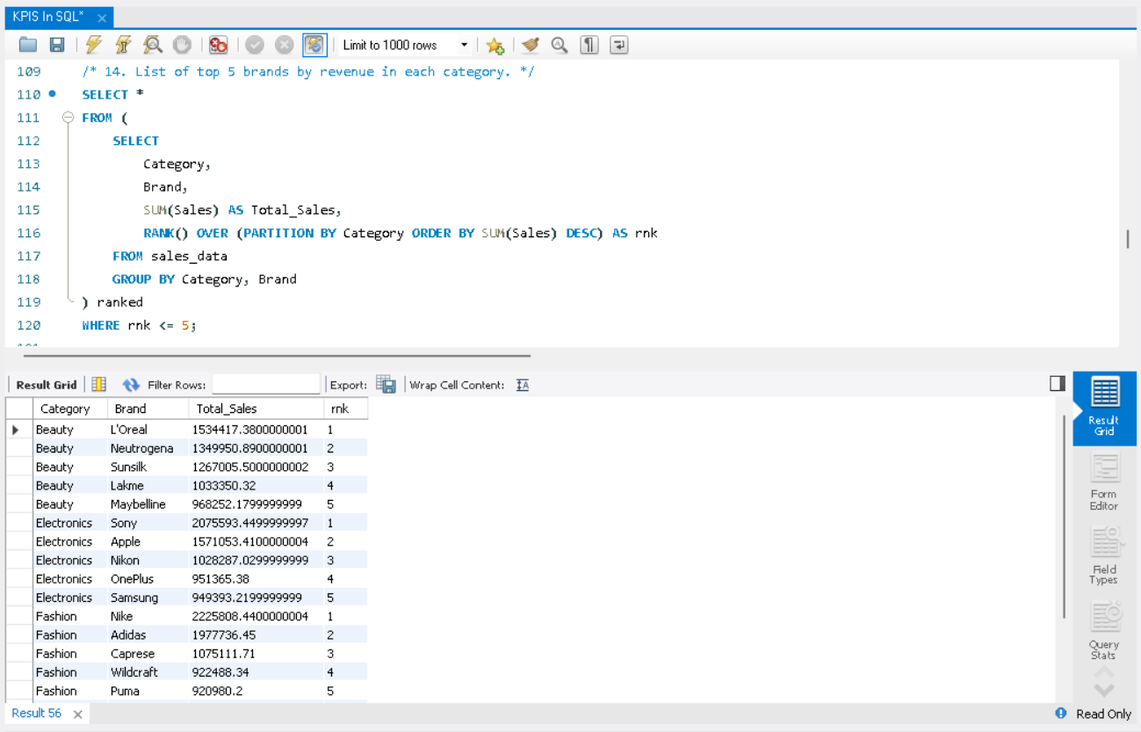

- Payment Mode Analysis
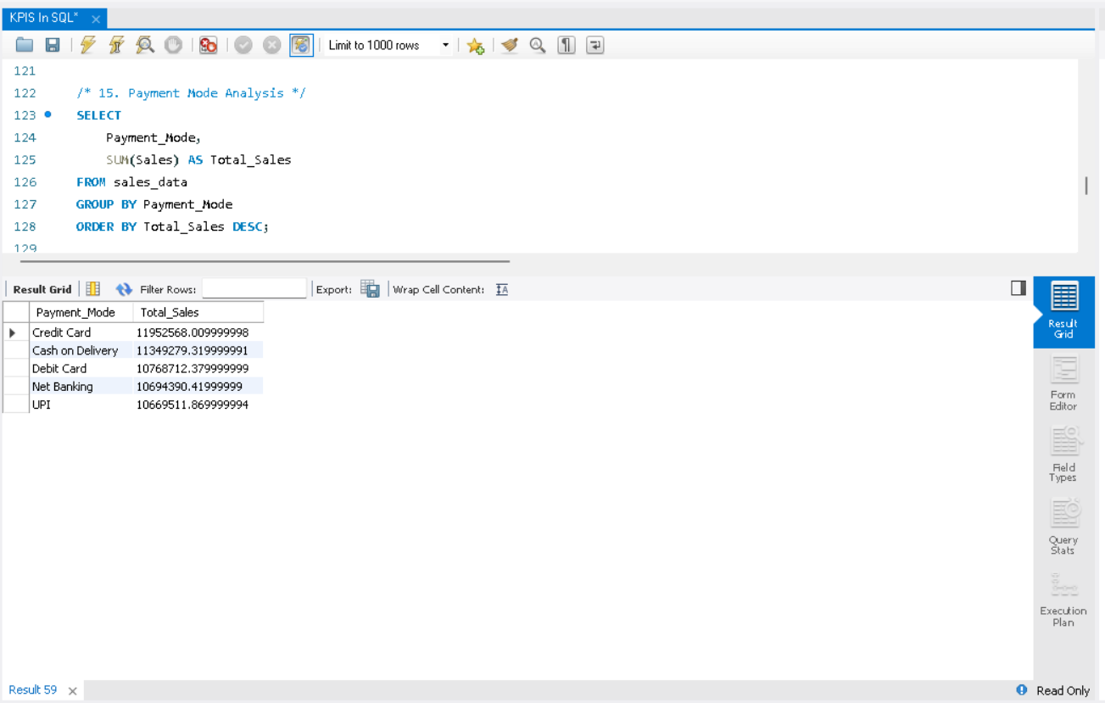

- Determine which payment mode contributed most to total sales.
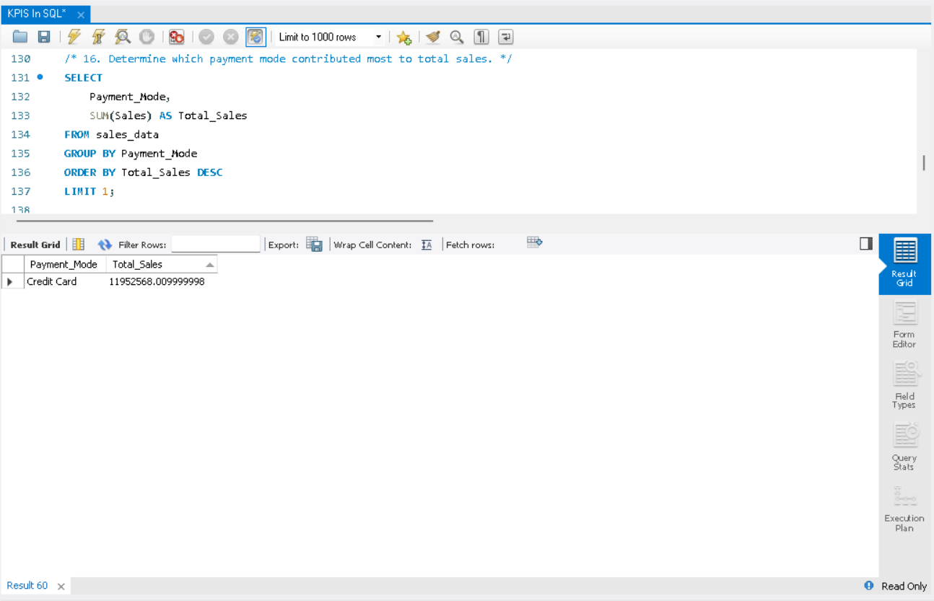

- Orders With Rating < 3
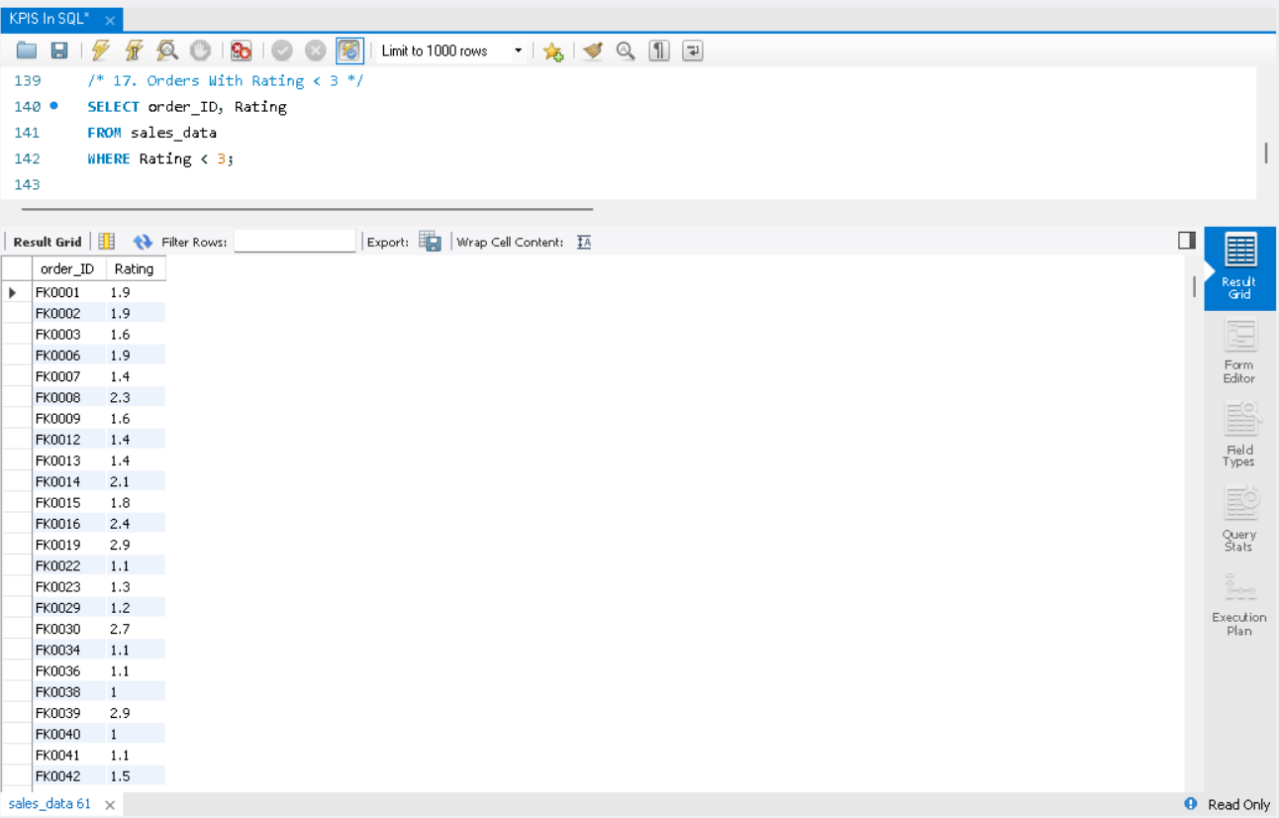

18. Retrieve all products where average customer rating is less than 3.
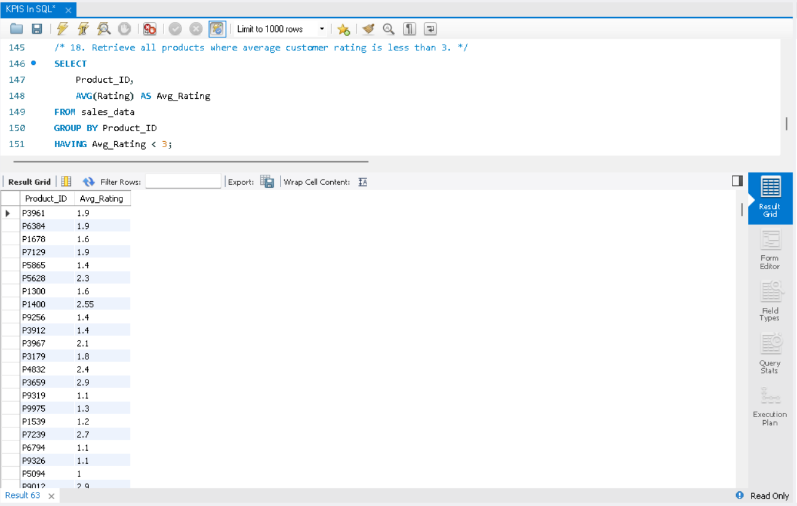

19.Year-over-Year Growth
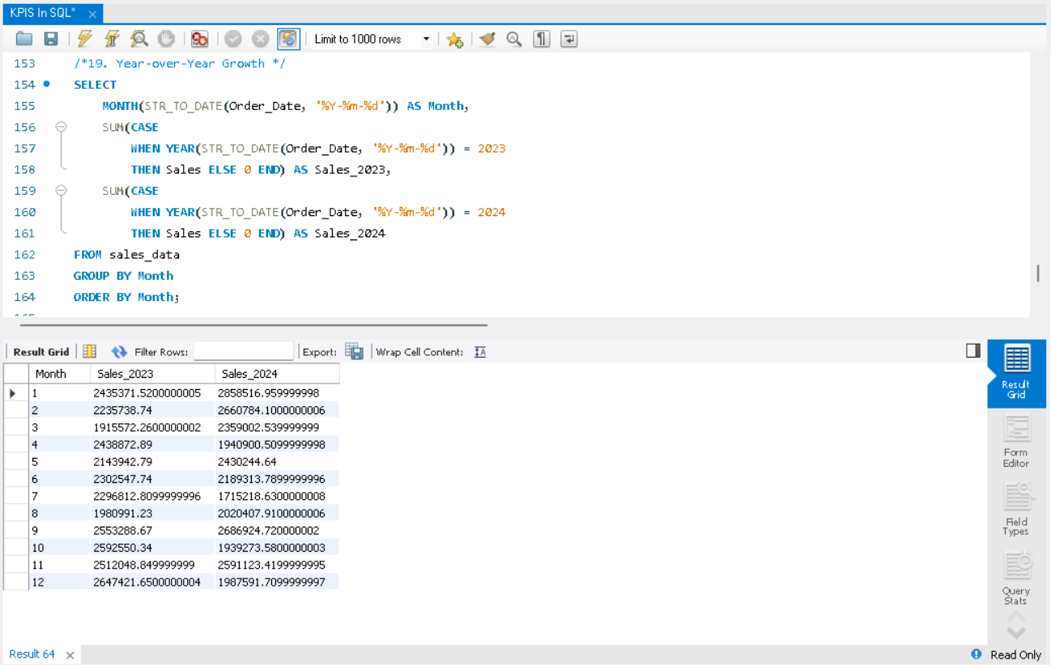

20. Compare total sales of 2023 vs 2024 by month.
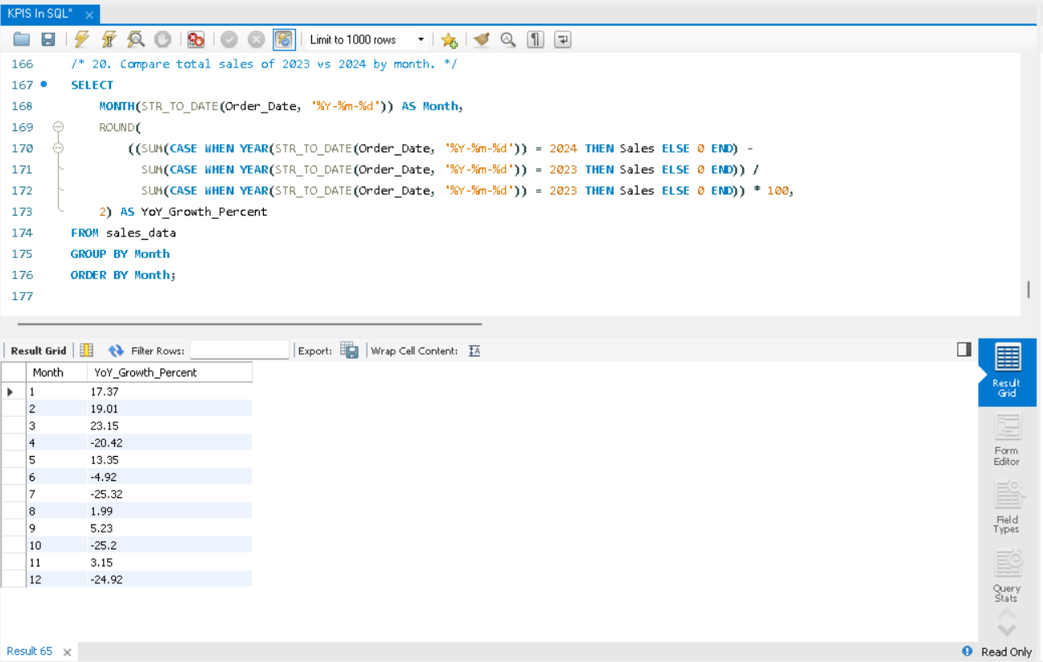

Excel Report

  - Section 2: Excel KPI

- Create a Pivot Table showing total sales per Category and Sub_Category.
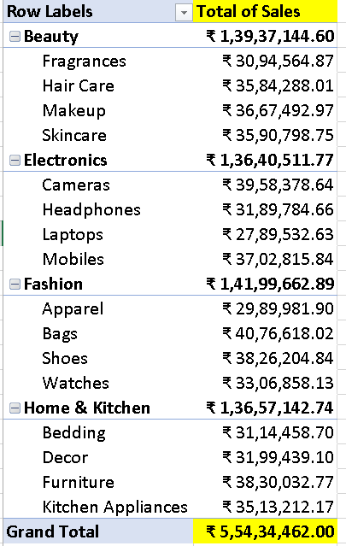

- Apply Conditional Formatting to highlight products with profit < 10%.
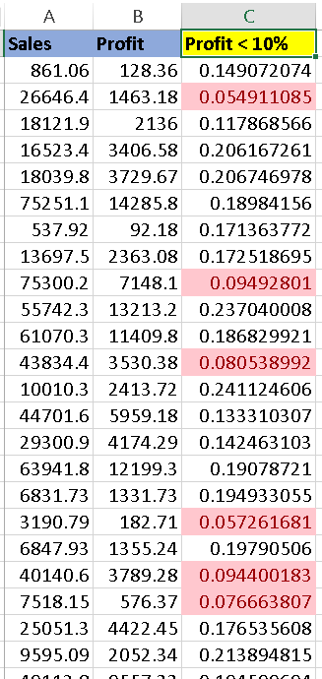

- Build a dynamic dashboard to filter sales by Region, Category, and Brand. 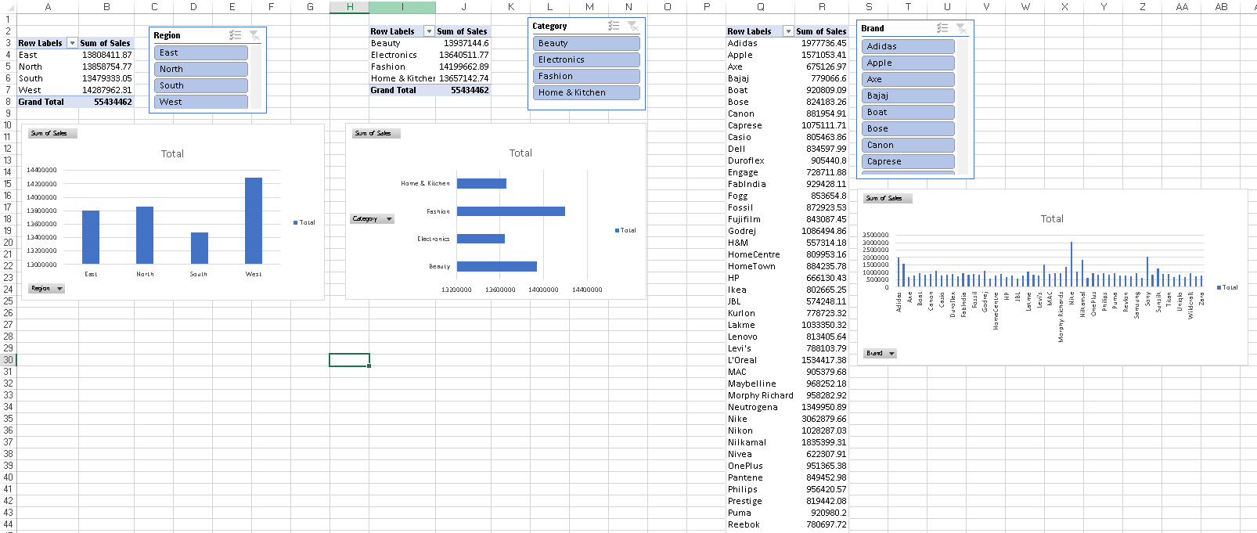

- Calculate total revenue per customer and highlight top 10 customers.
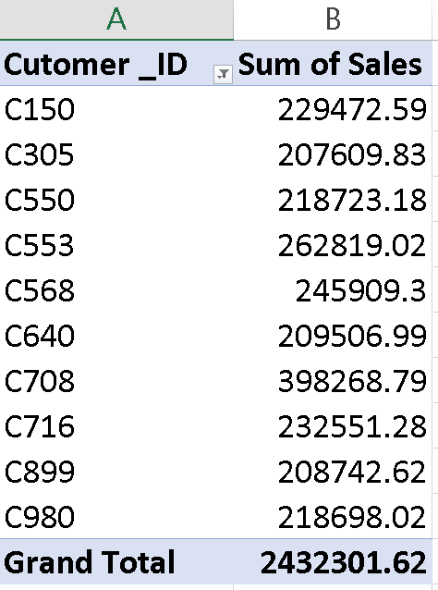

- Use formulas to calculate profit margin %: =Profit/Sales.

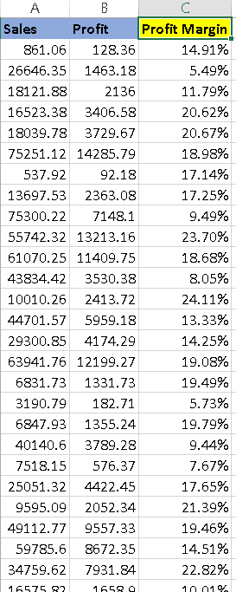

- Find average rating per brand using Pivot Table or formulas.
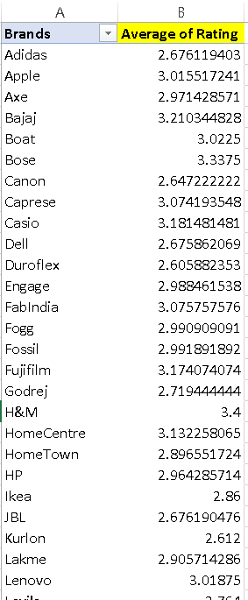

- Analyze monthly sales trends using Pivot Charts.
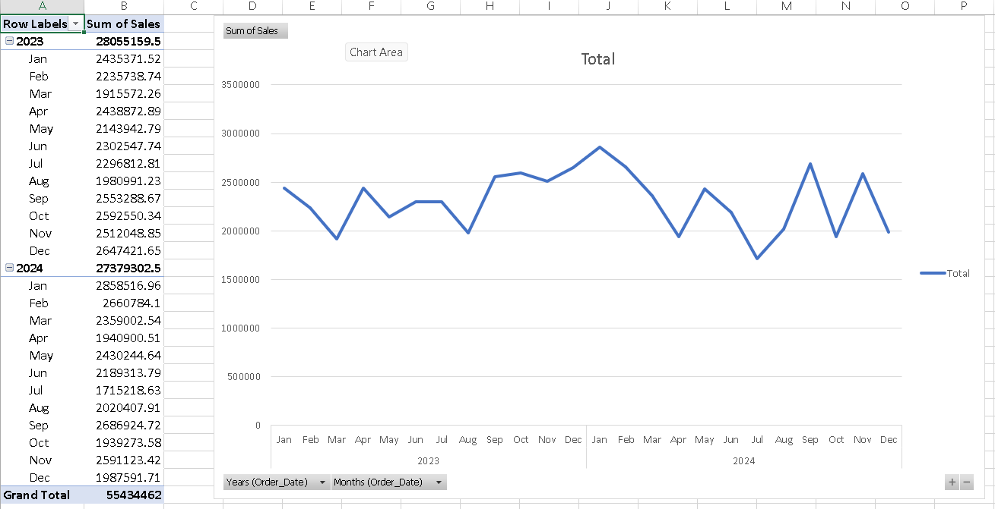

- Identify products with high discounts but low sales using filters/formulas.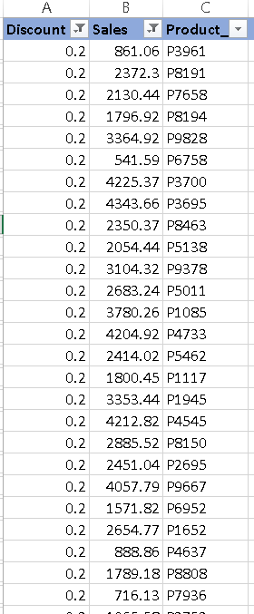

- Extract all orders from South region in 2024 using FILTER function.
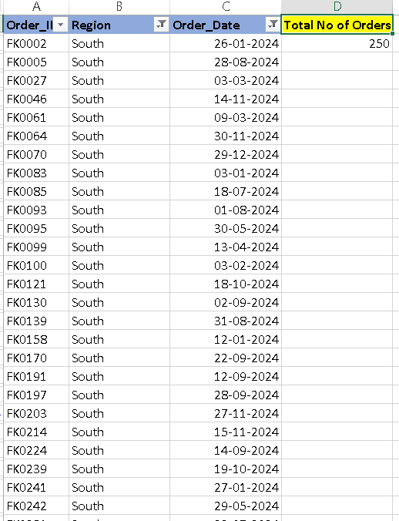

- Rank total quantity sold per sub-category using RANK.EQ().
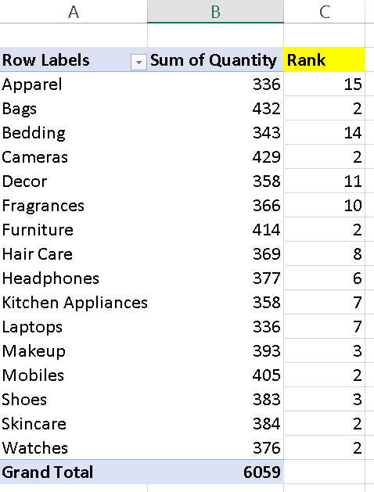

Power BI Report

Dashboard
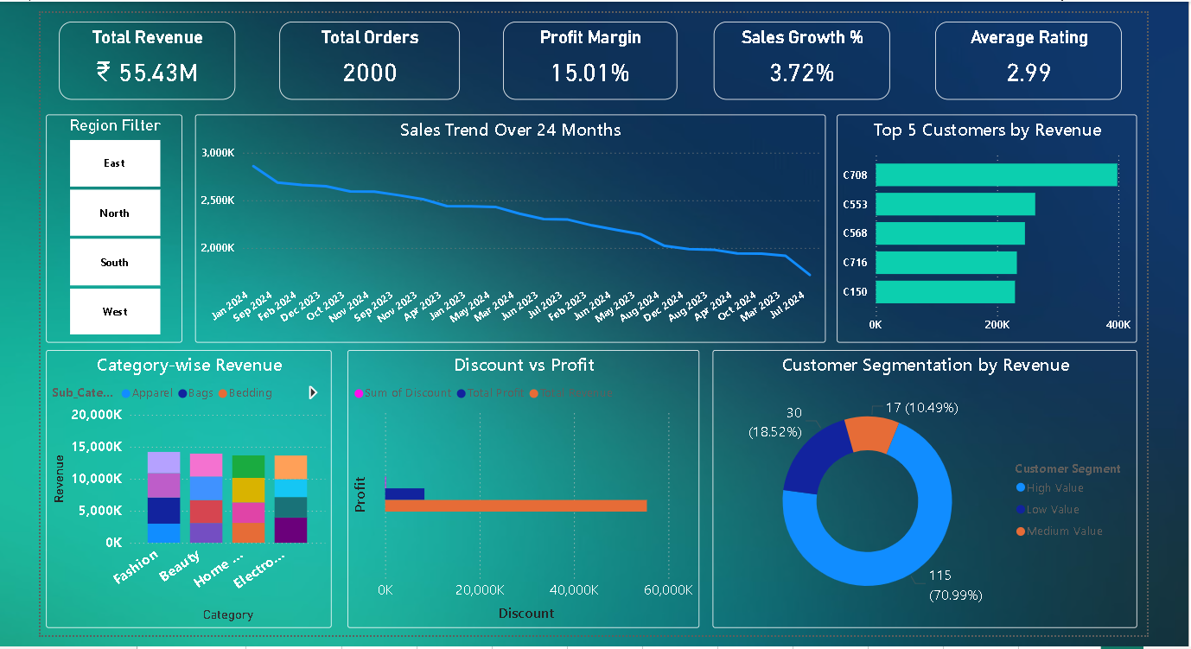

KPI Cards
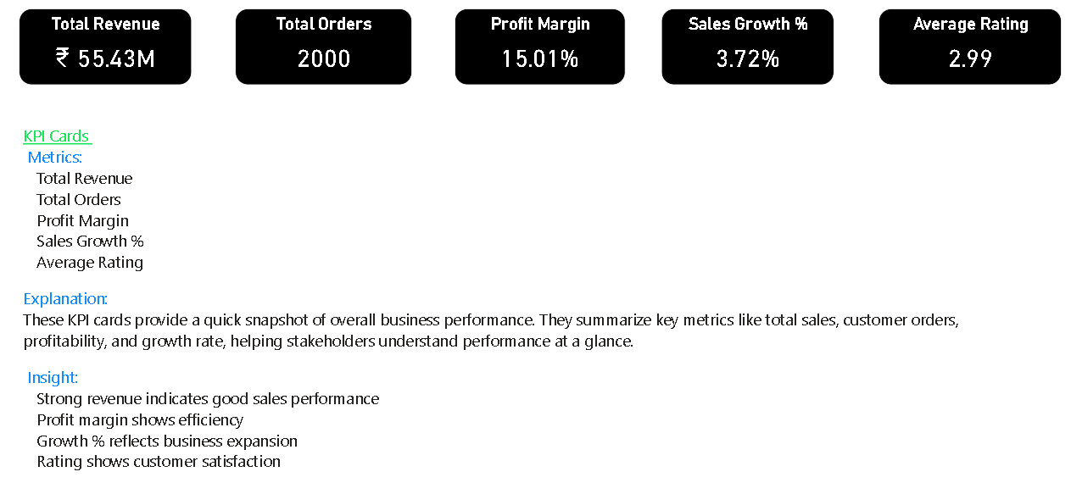

Section 3: Power BI KPI’s
- Build a dashboard showing sales trends over 24 months with region filters.
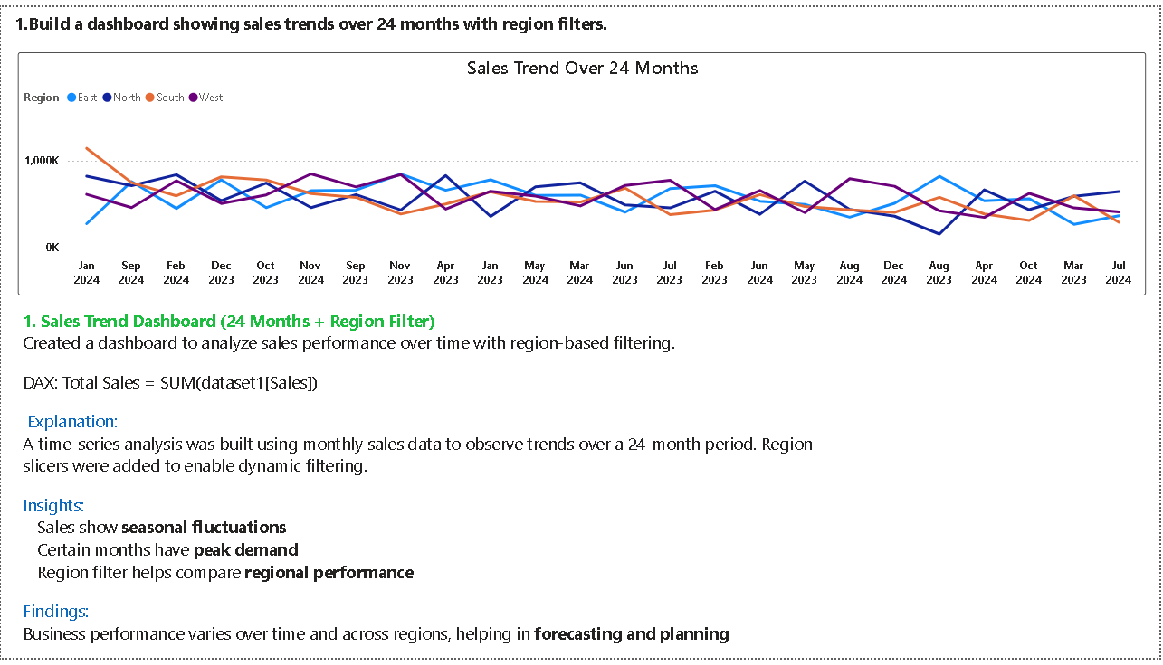

- Create a DAX measure for profit margin.
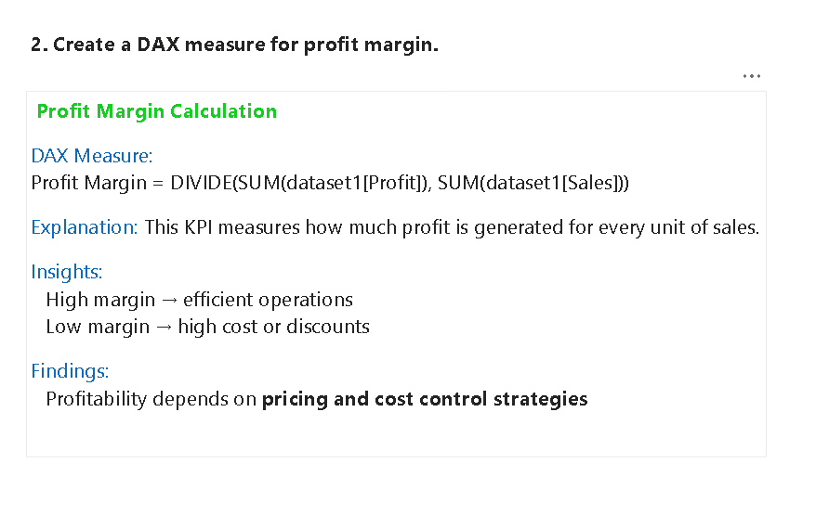

- Show top 5 customers by revenue using Top N filter.
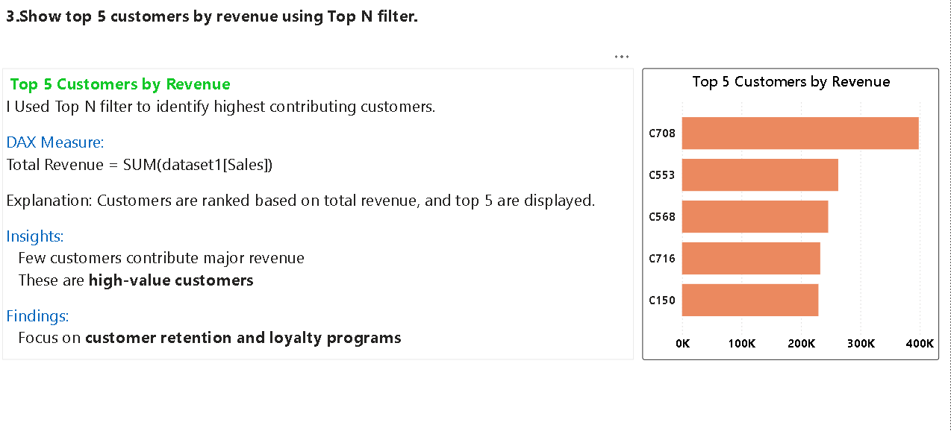

- Display category-wise revenue using a stacked column chart.
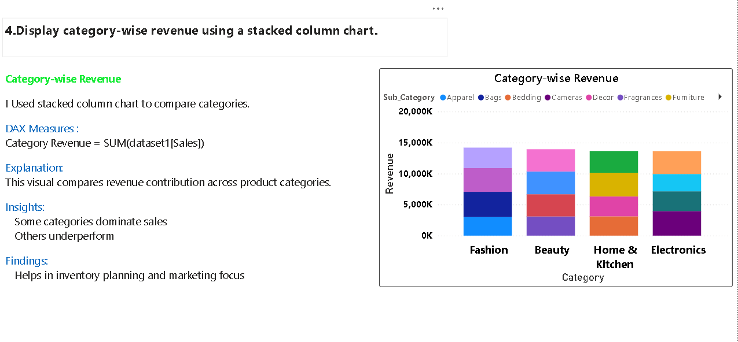

- Plot discount vs profit using a scatter chart.
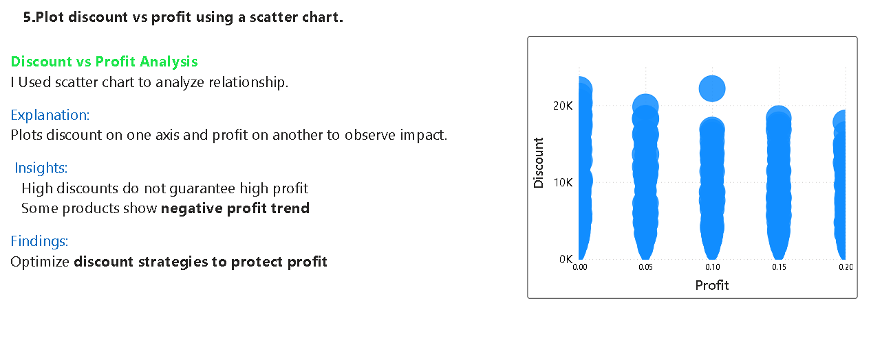

- Build RFM segmentation for customers.
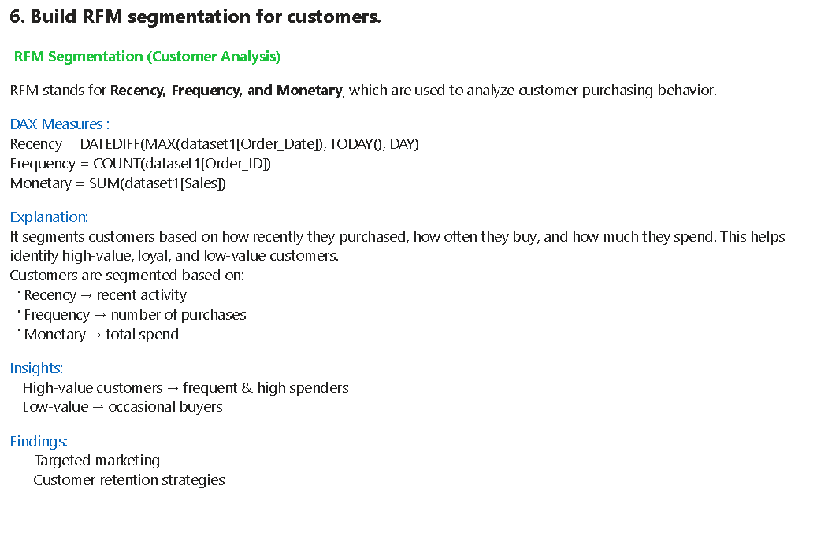

- Implement row-level security for region-based access.
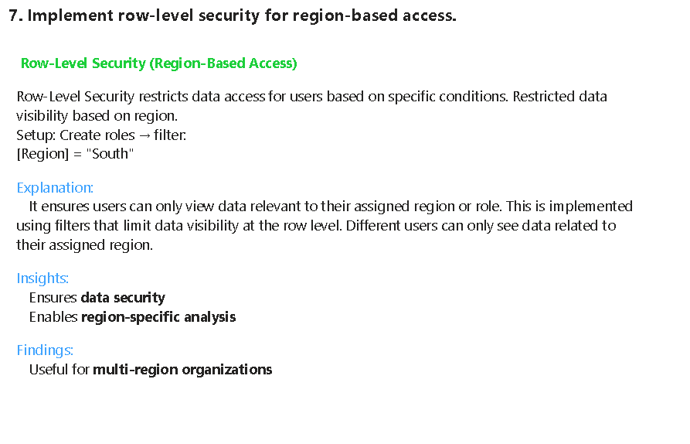

- Show average rating trend per brand over time.
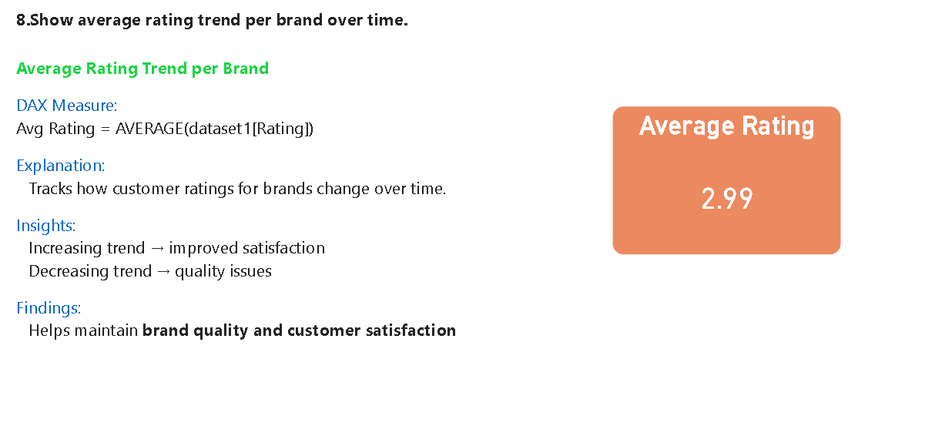

- Identify sub-categories with decreasing sales trend in last 6 months.
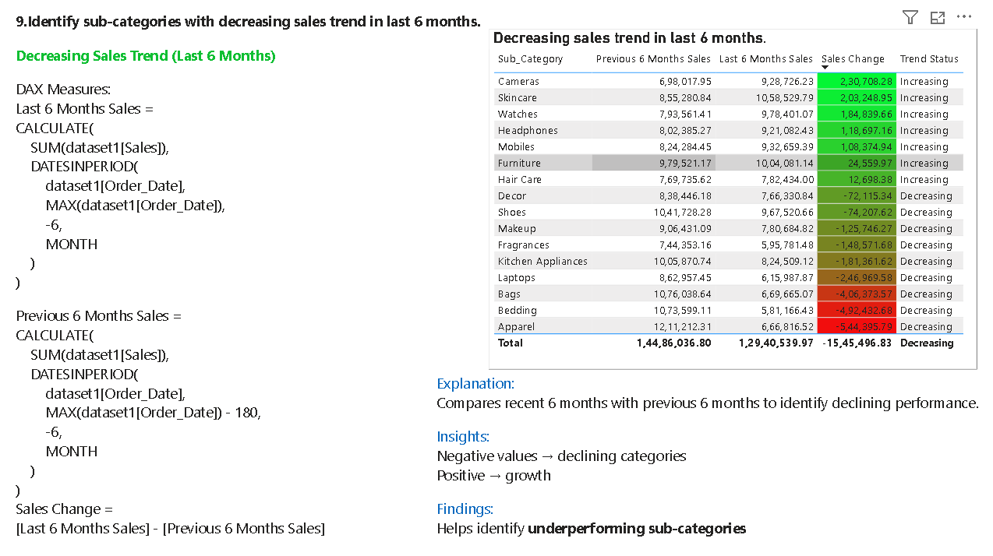

- Create a Pareto chart to show top 20% products contributing 80% of sales.
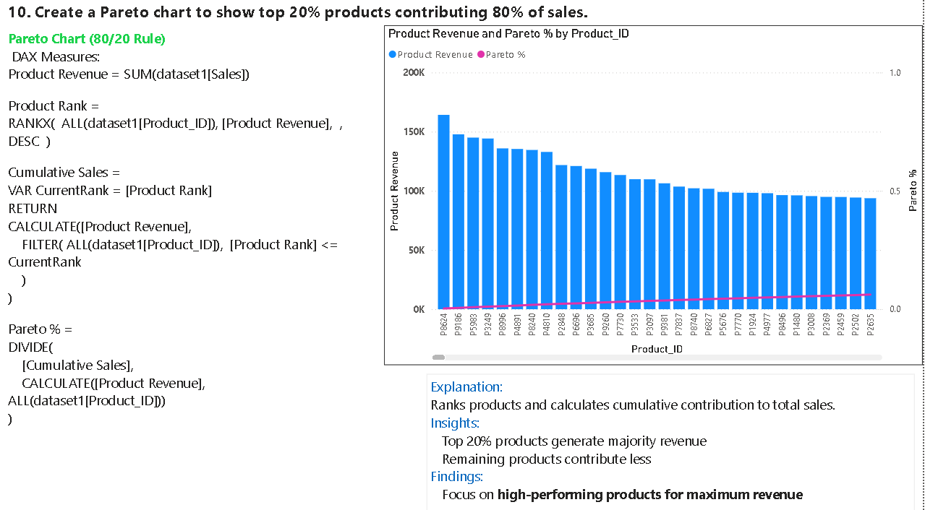
Key Findings
- Revenue Concentration
A small number of products contribute a large share of total sales
Indicates Pareto principle (80/20 rule) in business performance

- Customer Contribution
Top customers generate a significant portion of revenue
Presence of high-value repeat customers

- Sales Trend
Sales show monthly fluctuations and seasonal patterns
Certain periods consistently perform better

- Profitability Insights
High sales do not always result in high profit
Profit margin varies across categories due to discounts and costs

- Discount Impact
Higher discounts do not always increase sales
In some cases, they reduce profitability

- Category Performance
Some categories dominate revenue
Others have lower contribution and require improvement

- Customer Segmentation (RFM)
Customers can be grouped into high, medium, and low value
High-value customers are key to revenue growth
- Regional Performance
Sales performance differs across regions
Some regions contribute more revenue than others

- Product Quality (Ratings)
Products with low ratings indicate customer dissatisfaction
These require improvement to maintain brand reputation

- Growth Analysis
Year-over-Year comparison shows growth in some periods and decline in others
Helps identify areas for improvement
Business Recommendations
- Focus on High-Value Customers
Identify and retain top customers using loyalty programs and personalized offers

- Optimize Discount Strategy
Avoid unnecessary high discounts and apply them only where they boost sales

- Promote Top-Performing Products
Invest in marketing and ensure availability of best-selling products

- Improve Low-Performing Products
Fix issues in products with low sales or low ratings (quality, pricing, etc.)

- Strengthen Low-Performing Regions
Increase marketing and targeted campaigns in weaker regions

Final Conclusion
The analysis includes Power BI visualization to provide a comprehensive view of business performance. The dashboard highlights key aspects such as sales trends, customer behaviour, product contribution, and profitability. By combining time-based analysis, customer segmentation, and product-level insights, the report enables data-driven decision-making. Overall, the business performance is driven by a limited set of high-value customers and products, while profitability and growth depend on effective pricing, discount strategies, and regional performance optimization.

Python Report

Section 4: Python (pandas) KPI
- Load the dataset and display first 10 rows.

The dataset is loaded using pandas.read_csv() into a DataFrame. The head(10) function is used to display the first 10 rows to understand the structure, column names, and data types.
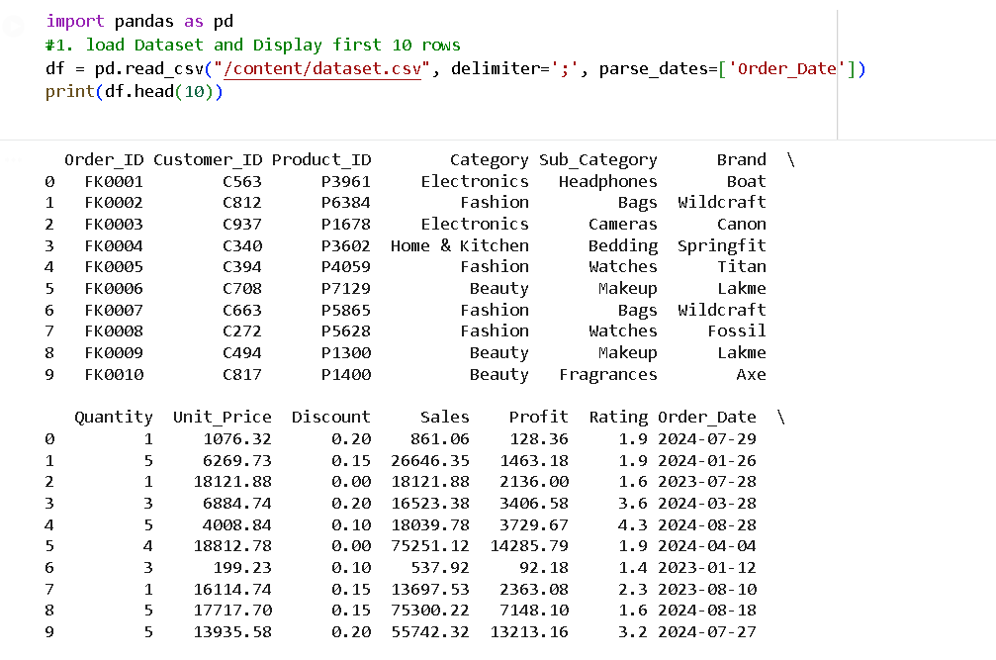
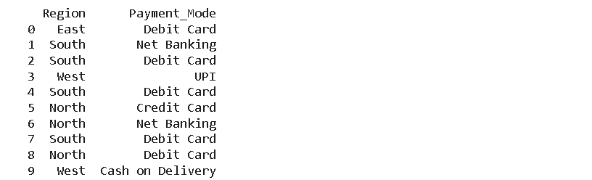

- Calculate total sales and profit per category.

The groupby("Category") function groups the data by product category, and sum() calculates total sales and profit for each category.

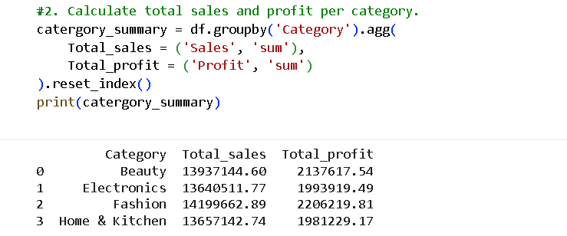

- Identify customers with highest total orders.

The data is grouped by Customer_ID, and the number of orders is calculated using count(). The results are sorted in descending order to find top customers.
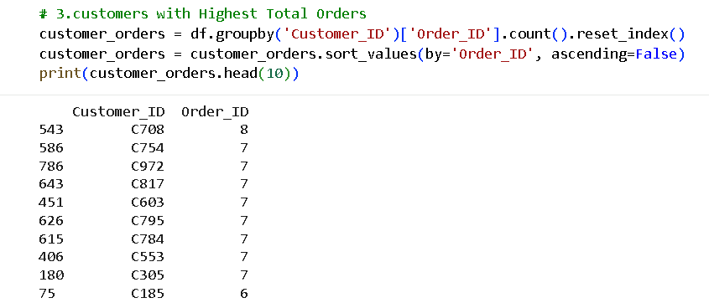

- Plot monthly sales trend using matplotlib/seaborn.

The Order_Date column is converted to datetime format, and a new Month_Year column is created. Sales are aggregated monthly and visualized using a line chart.
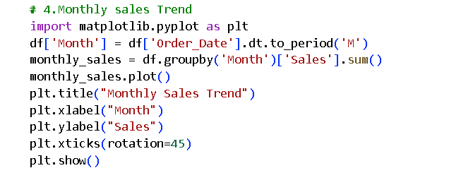

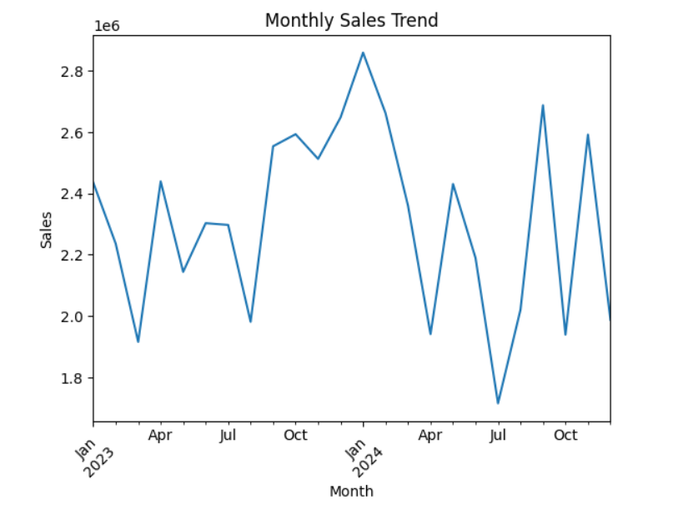

- Find products with average rating < 3.

The dataset is grouped by Product_ID, and the average rating is calculated. Products with ratings less than 3 are filtered.
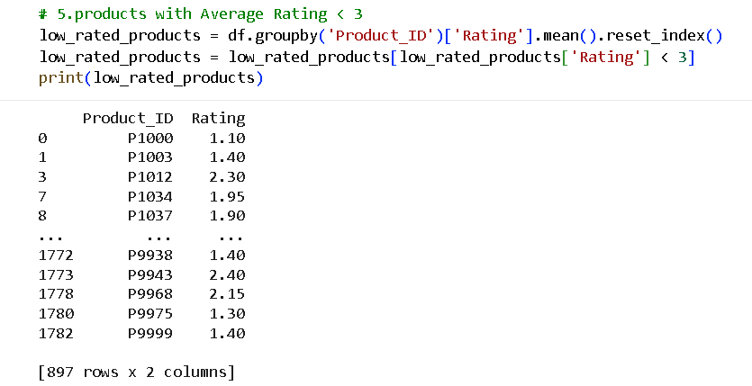

- Add a new column for profit margin %.

A new column is created by dividing profit by sales and multiplying by 100 to calculate the profit margin percentage for each record.

- Filter orders in 2024 and Region='South'

The dataset is filtered using conditions on year (2024) and region (South). Only relevant records are extracted.
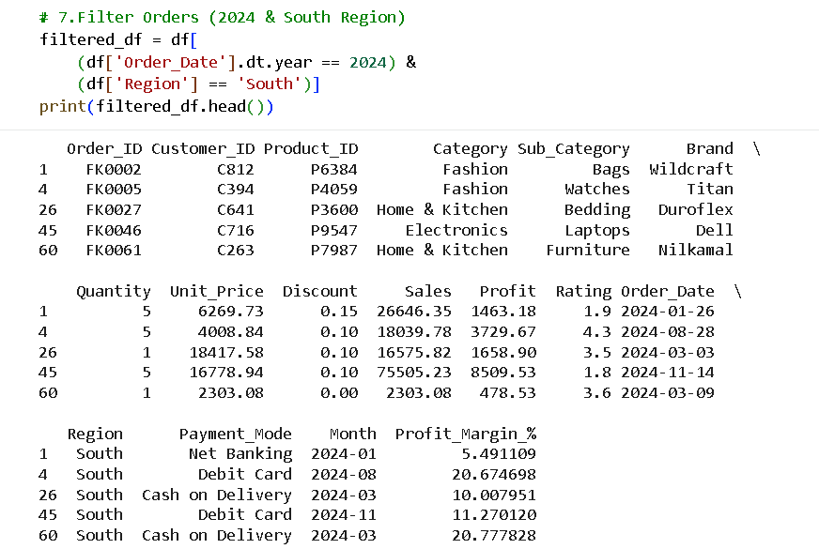

- Determine top 10 brands by total sales using groupby and sort_values.

The data is grouped by Brand, total sales are calculated, and sorted in descending order to get the top 10 brands.
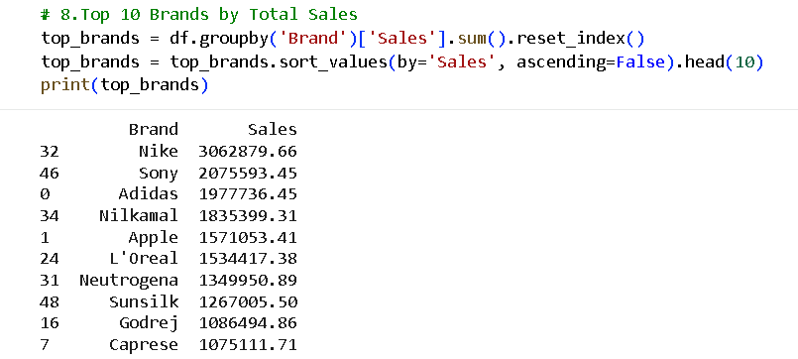
- Detect outliers in unit price using IQR or z-score.

The IQR (Interquartile Range) method is used to calculate lower and upper bounds. Values outside this range are considered outliers.

- Export summary report with total sales, profit, and quantity per category to Excel.

Category-level summary (sales, profit, quantity) is created using groupby(), and exported using to_excel().
